# Basic CSS rules:

* <style> tag should go in head section. Order: meta, title, and style.
* You can group CSS selectors to apply same style to different groups

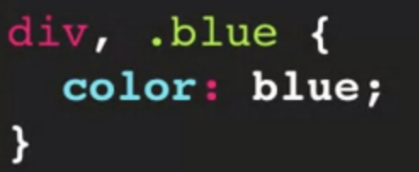

* You can use CSS selector combinations to define styles.

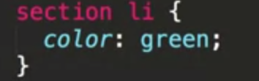

* You can also use pseudo selectors.

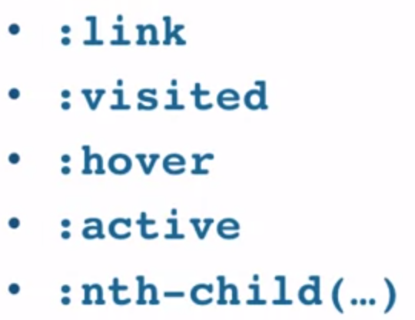

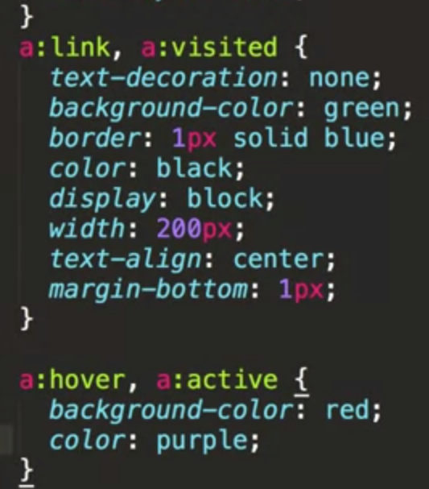

* If you place style inside the element, you should do it like this

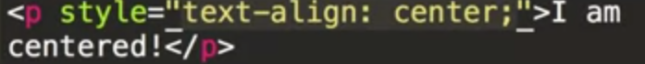

* External stylesheet must be inside <link> tag, and should look like this



* Head styles are sometimes used to override external styles. We never use inline styles.
* If the same element is targeted from different places, the last declaration will wins. **This is only in regard of external, head and inline declarations. If both declarations are written in same section, lets say head.. then the declaration that wins will be decided by specificity.**  Unless, targeted element has different properties (let say in one declaration is the color and in the last one is the text size). In such case it will merge and both declarations will take effect.
* If you declare a certain style to an element then all the children inside that element will also get the same style properties.
* Specificity works like this:

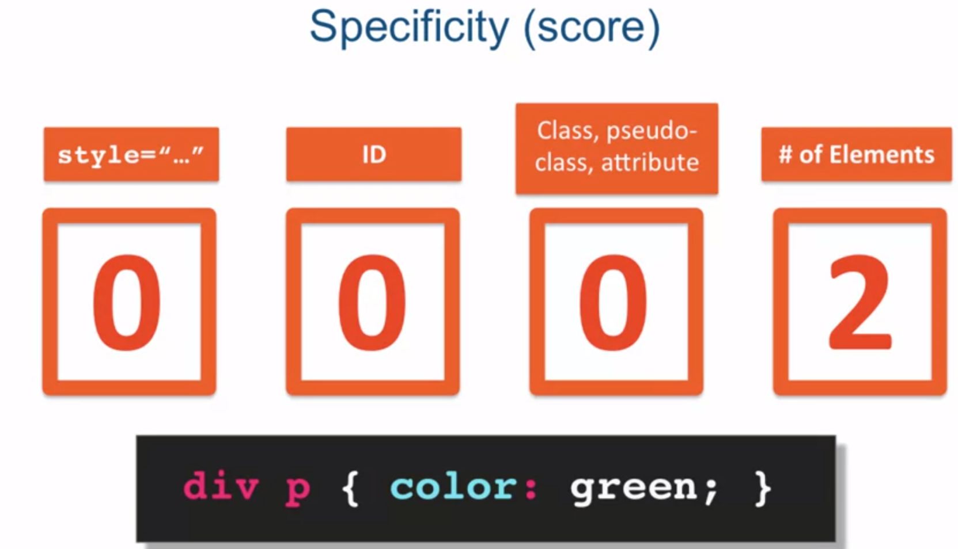 only 2 points

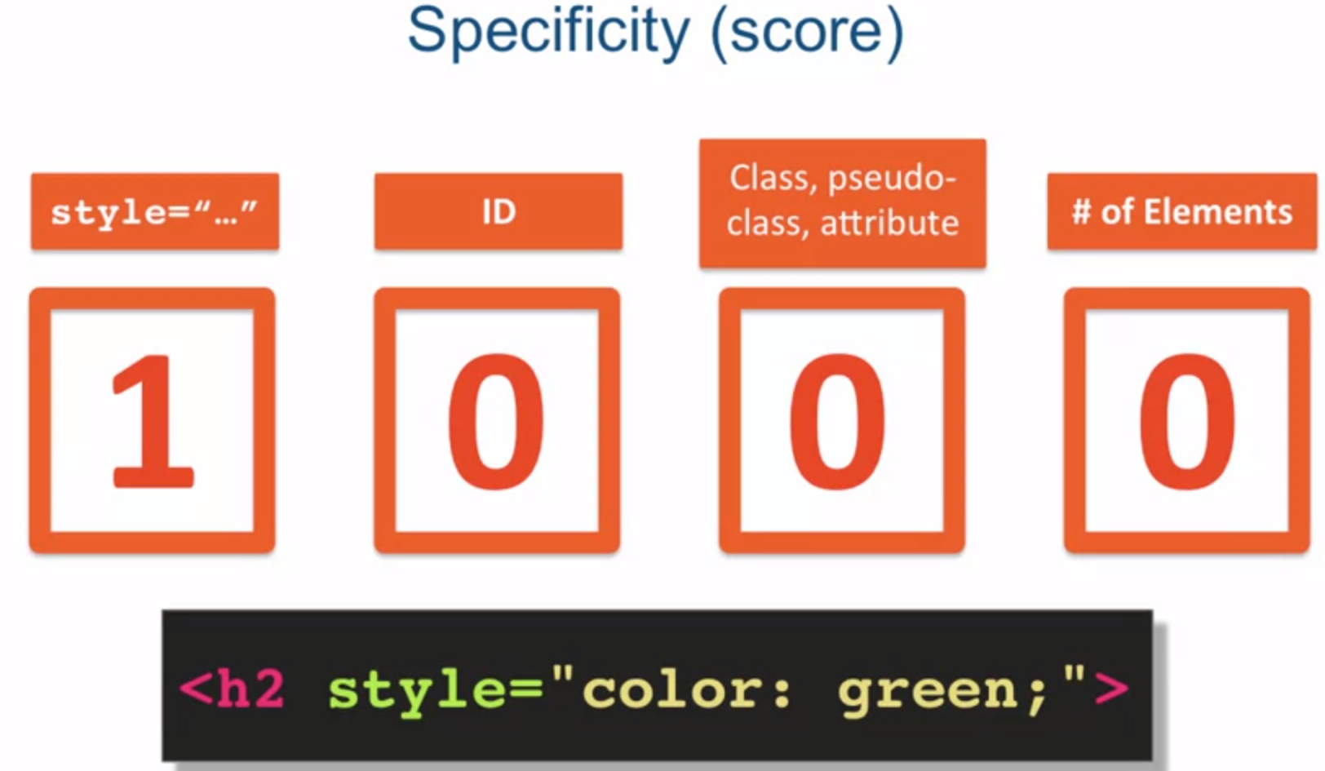 1000 points (top score)

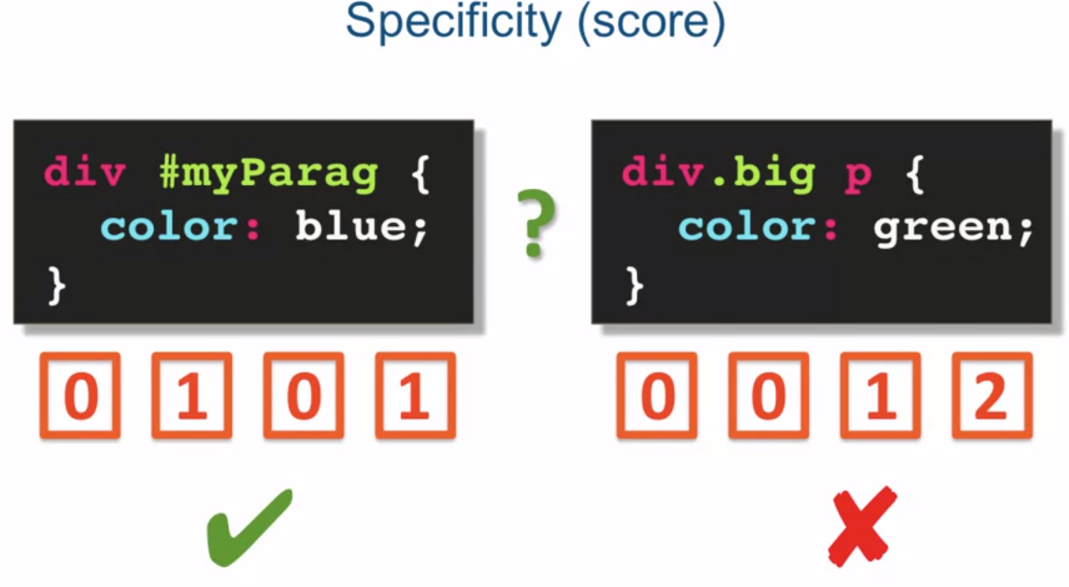

* Some style properties

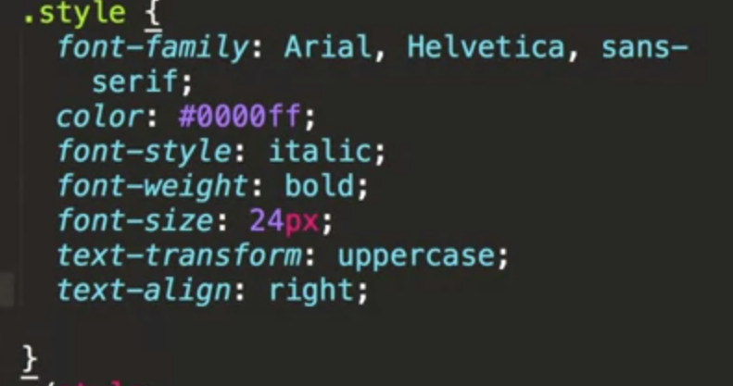

* If we use relative font options then it merges but not overrides each other.

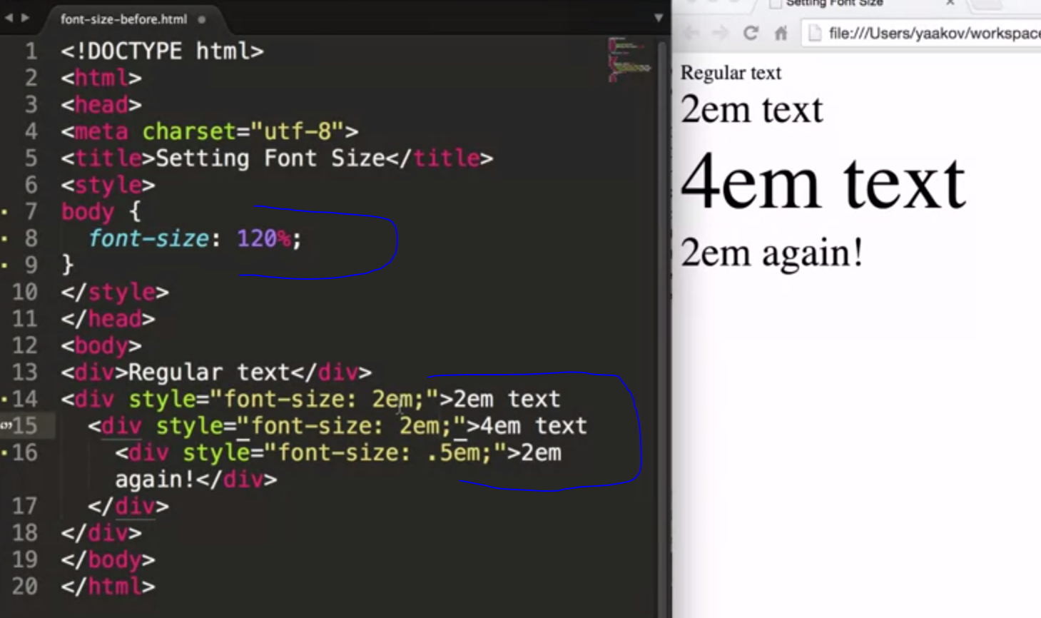

* Each element in html is considered a box. A box consists of:

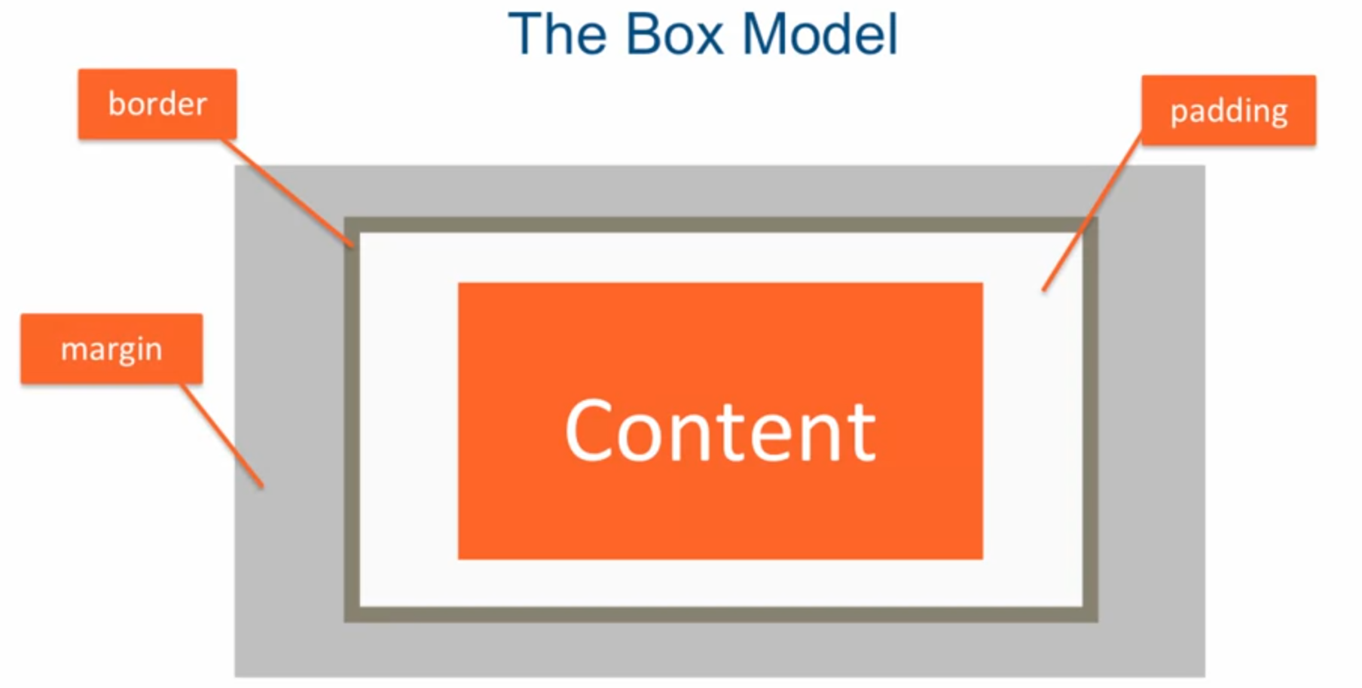

* Be careful with boxes. With “width” you will set content box, and padding and border will be extra. If you want it to be exactly as the width you specified, you have to add “box-sizing: border-box” property, which makes the width to be content, padding and border. Look at the picture below. Default is, as mentioned above, “box-sizing: content-box”.

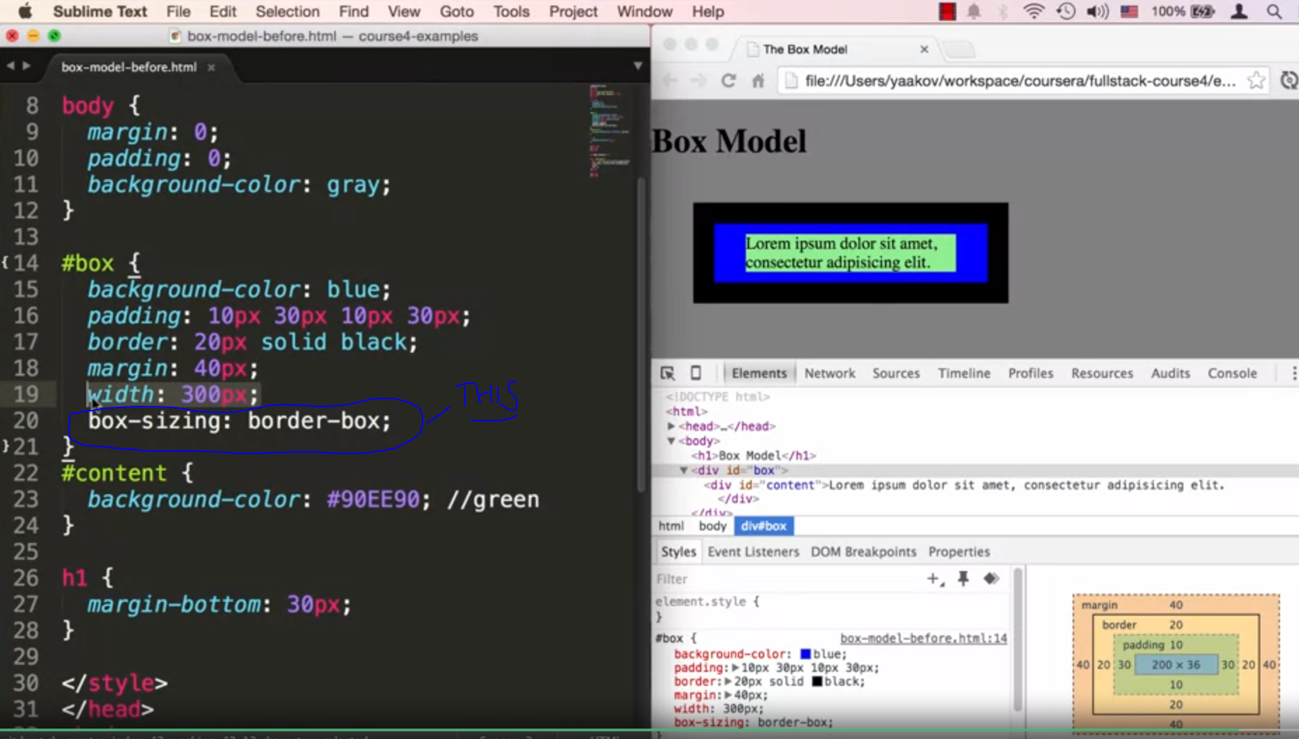

* “box-sizing: border-box” is not inherited by other elements like other properties. I you want to set it for the whole document you must place it with *.

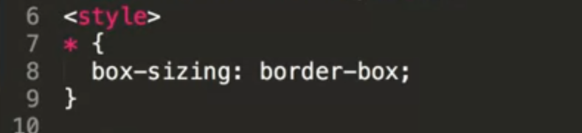

* Cumulative Margins: **Horizontal.** Works normally as expected, the total is the sum of both margins.

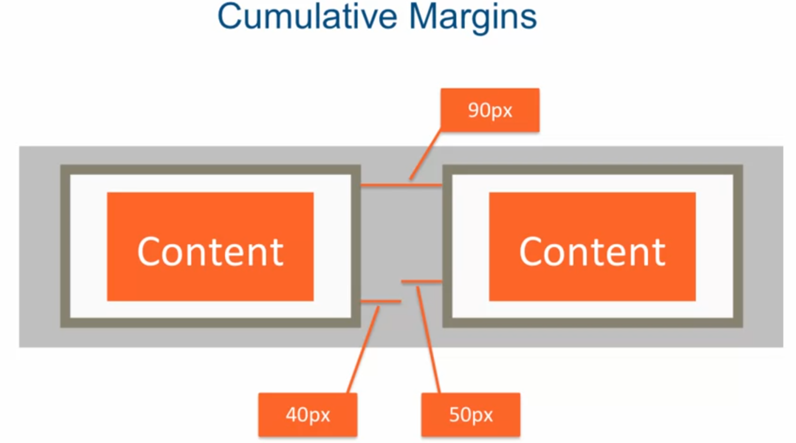

* Cumulative Margins: **Vertical.** With vertical the margins collapse and the larger margin wins.

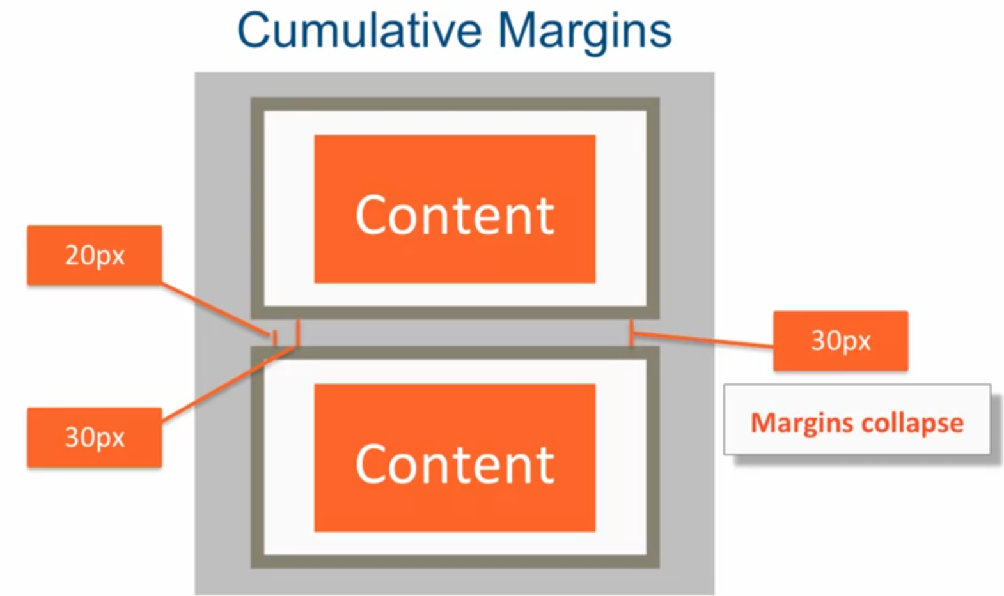

* if text does not fit in small box, you can always use “**overflow**” property, which has a few options. Options: auto - adds scrollers, hidden – only shows the text until the box ends, visible – is a default option and it goes over board which does not look nice as it collides with following elements.

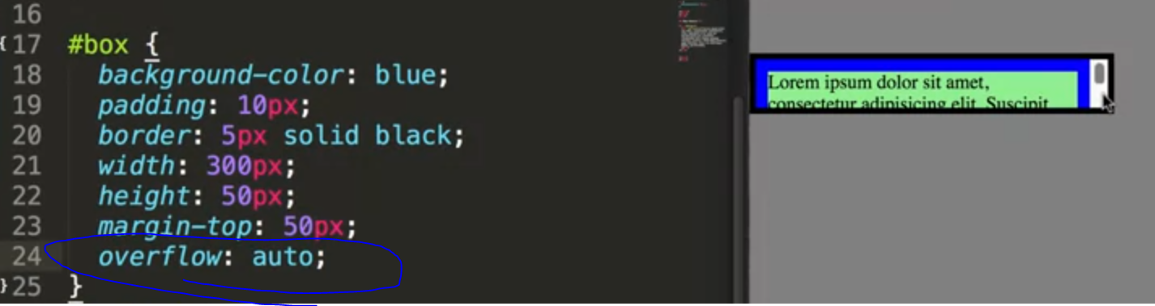

* some background options. By the way image wins over the background color. Also with background position you should specify 2 properties, if one given the other one becomes center automatically.

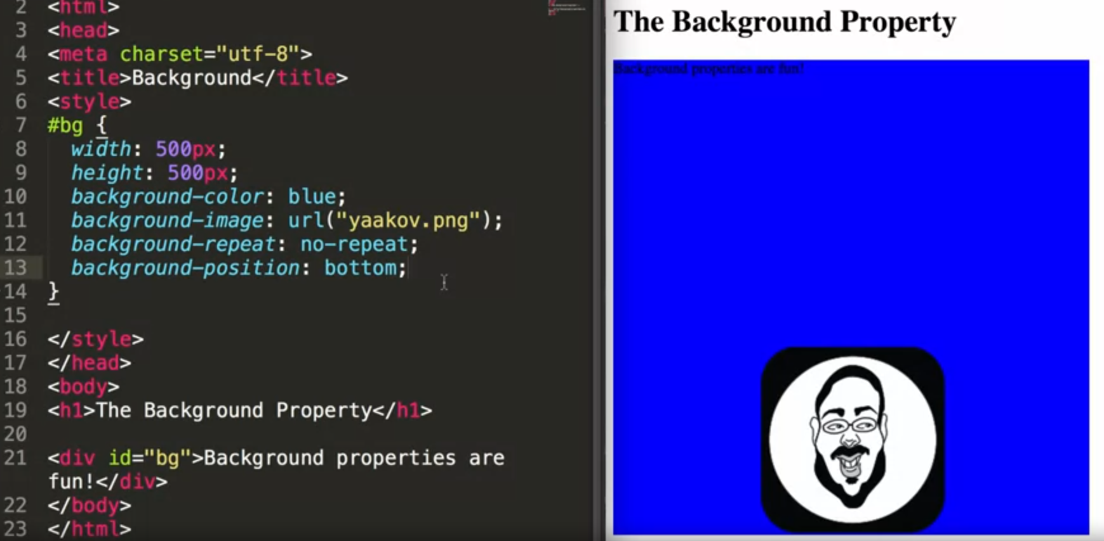

* background property overrides every specific background property (for example: background-color). The key here is that it is with “-“ and specific property. That’s why the color is gone on the page.

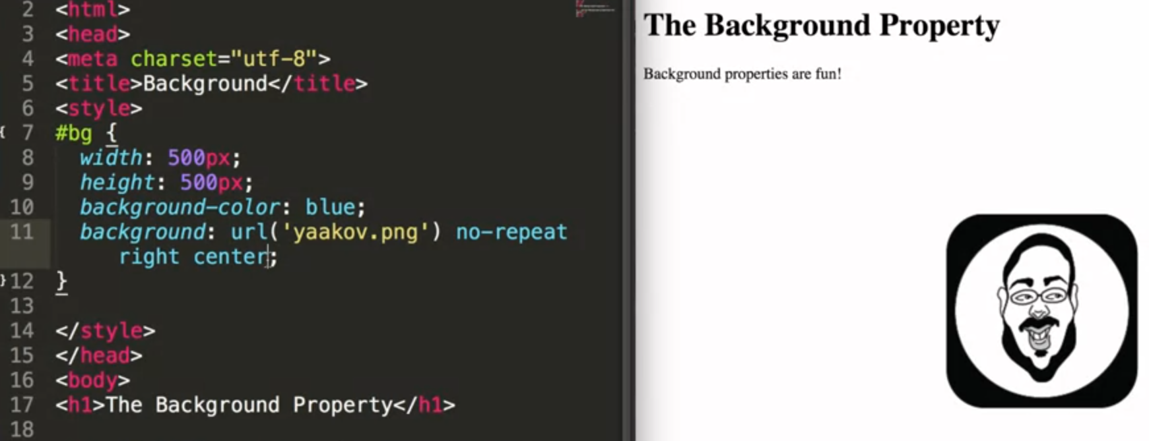

* you can add everything in “background”.

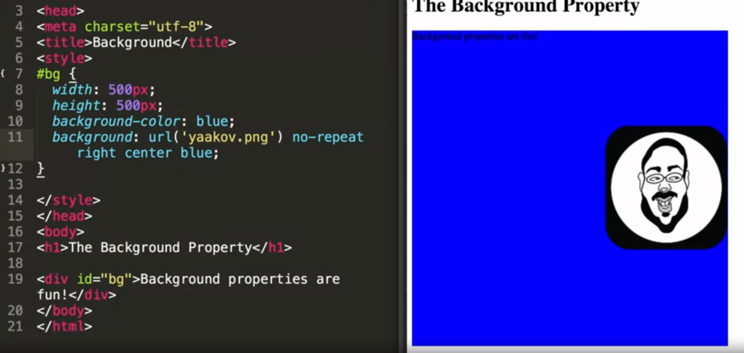

* floating seems to be a bit complicated, need to watch a video again.

Important regarding “CLEAR”. When you use clear, let’s say **clear: left**

It means that nothing is allowed to move left of that tag that we used clear. This element moves back and, but has nothing in front of it from the left side. In general if u use left and want the next element not to be eaffected use the same direction, which in this case is left.

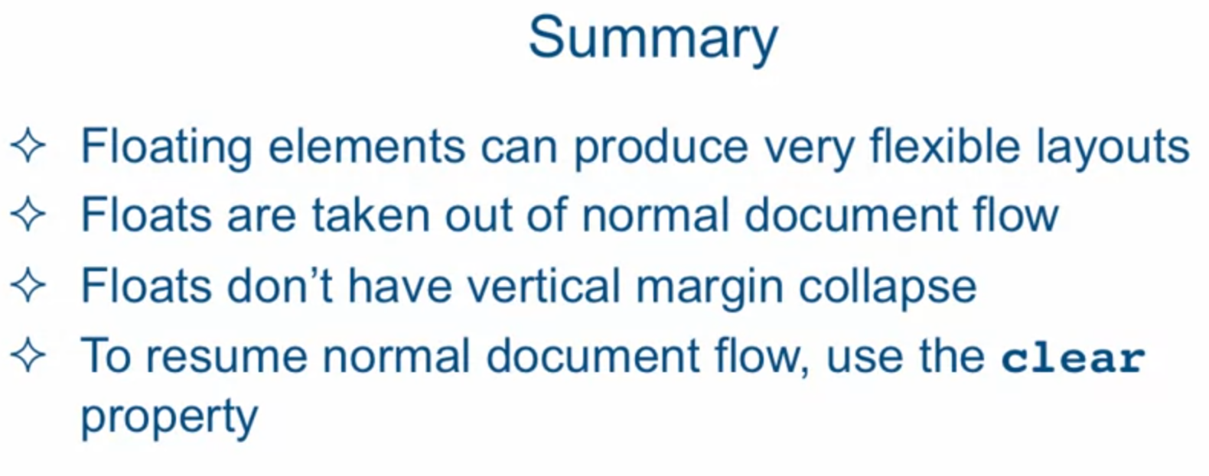

* Relative position means that you take, either left, right, top or bottom of the document base and position it to the property you chose. The rest of the document assumes that the element is still there and does not change. Like in this example. Smaller orange rectangle stays in its original position despite the fact that the big one was relatively moved from top and from left. You think of top as “from top” and left as “from left”.

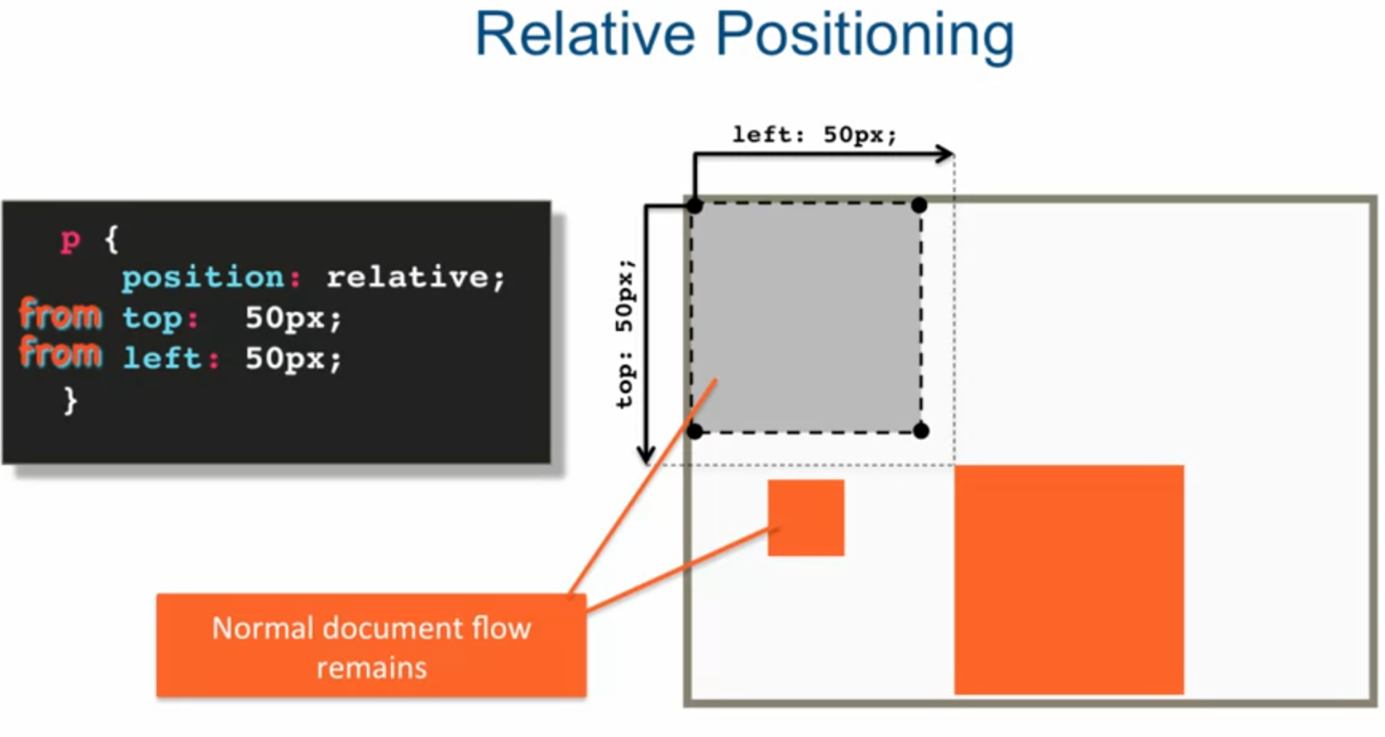

* Absolute positioning. If we use absolute positioning on the element, we take this element of normal flow. The rest works as with relative positioning. The only difference is that the document that has absolute property is moved somewhere and the following elements move to its position. A thing to remember is that when we set element an absolute position it takes all the elements inside with it.

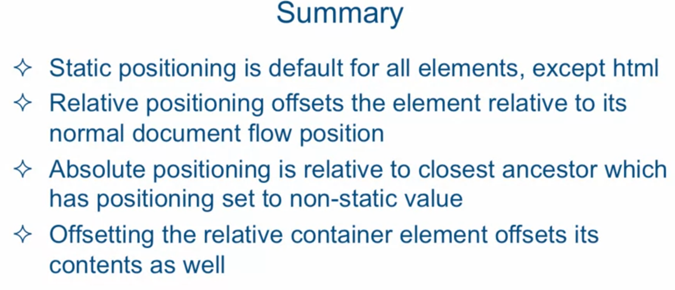

* Media Query syntax

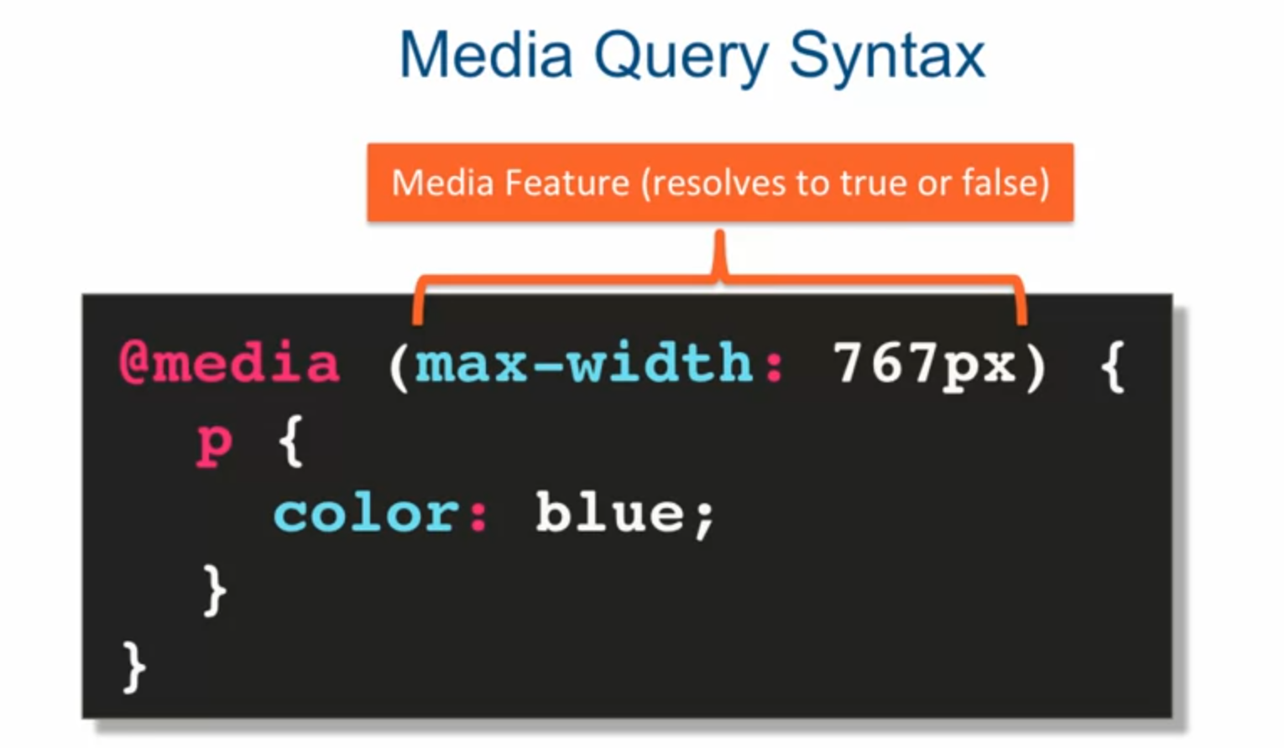

* Other media query features:

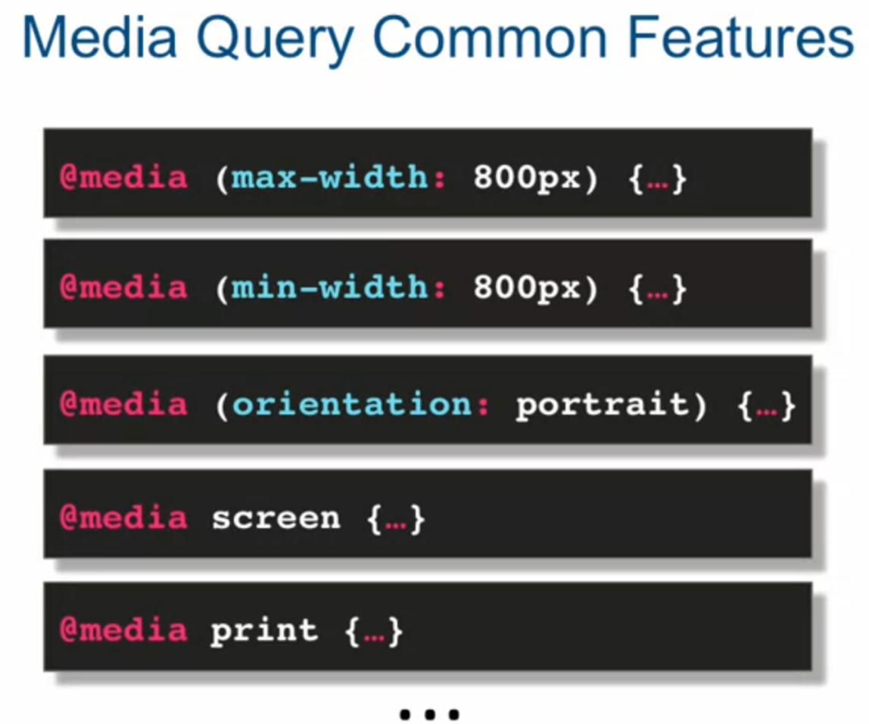

* Media query, devices with width within a range

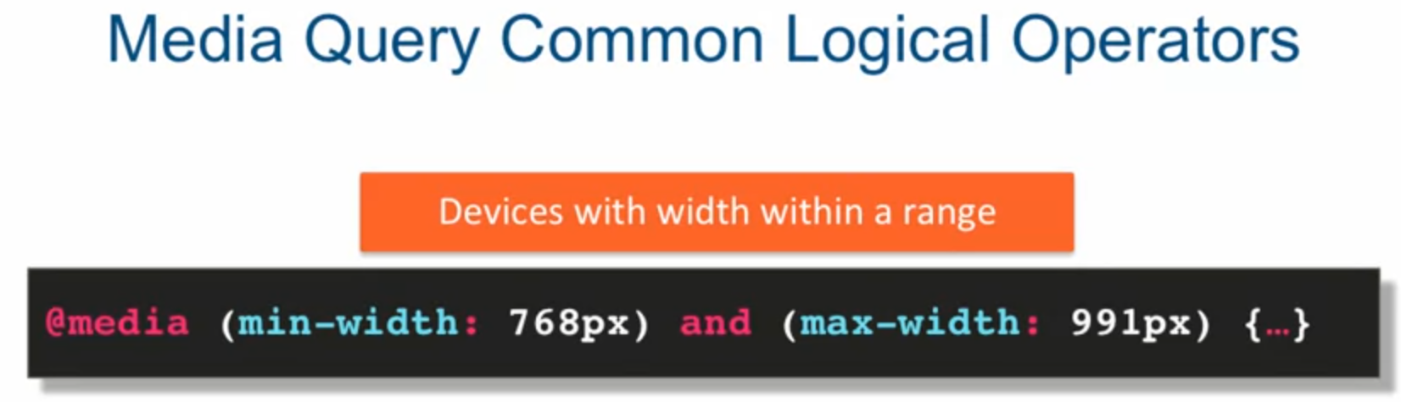

* Another way to do the same

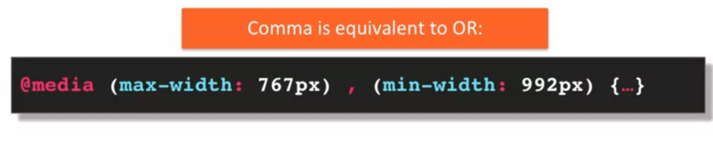

* Approach of doing media query

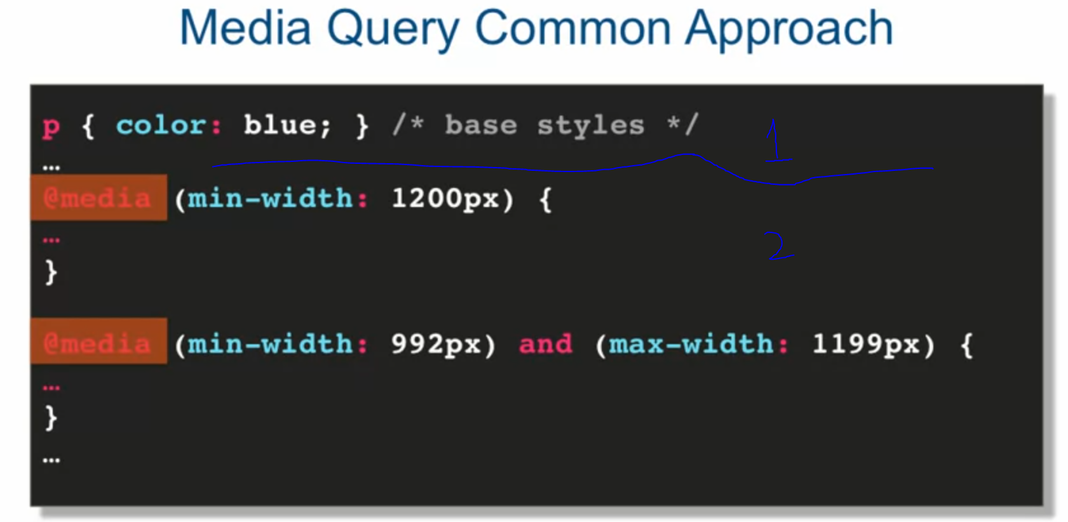



* 12 – column grid responsive layout

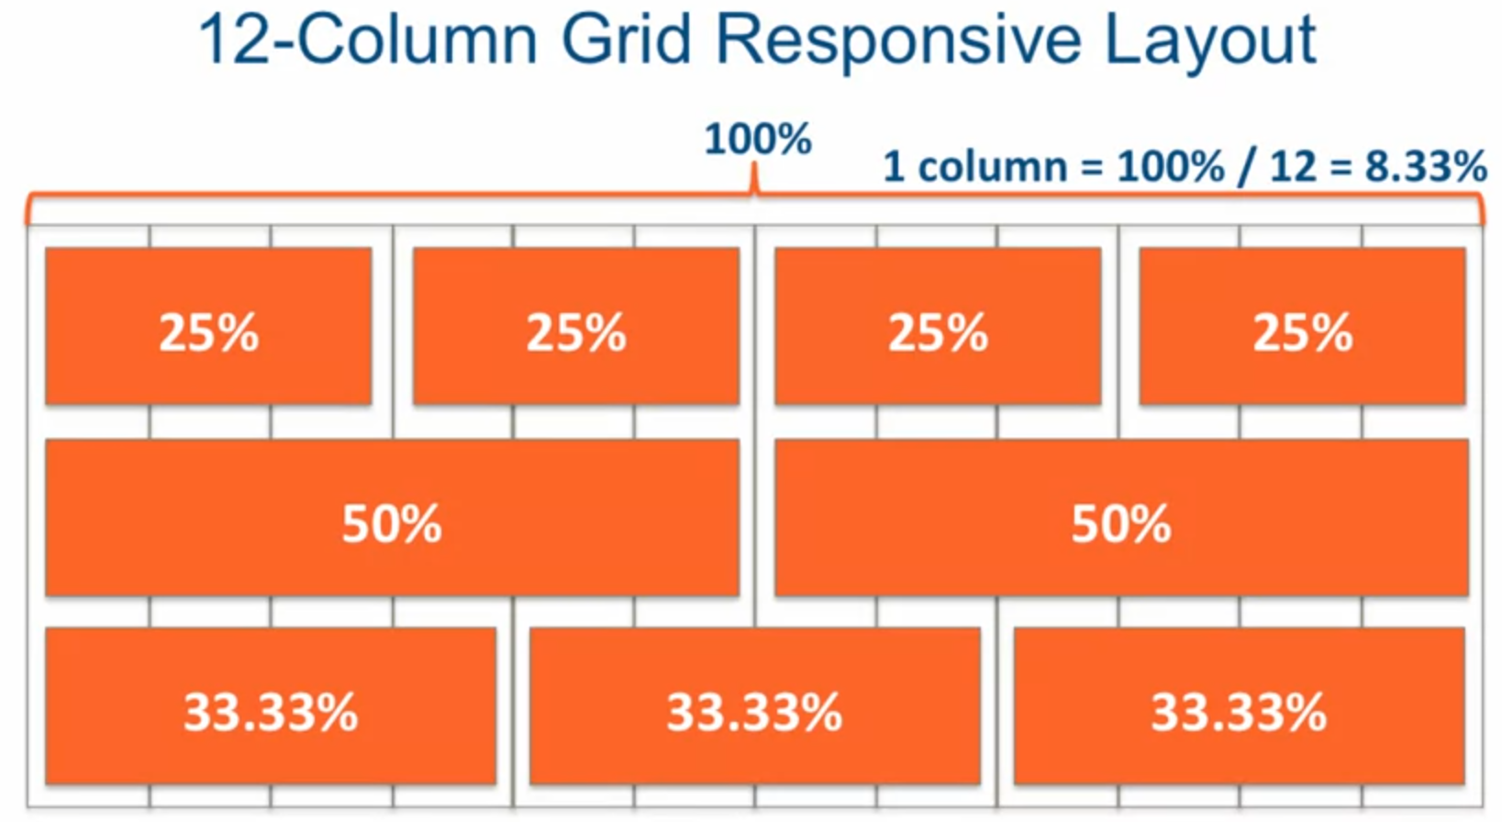

* To achieve the correct website sizing we need to include one line in our style.



* What is bootstrap?

